**Year 10 Physics Revision**

**1** What distance would a bike, ridden at a speed of 10 centimetres per second, cover in an hour? (Distance = Speed x Time)

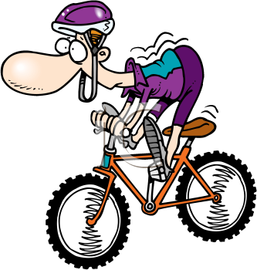

**2** Draw a suspension bridge

Which part is in compression?

Which part is in tension?

[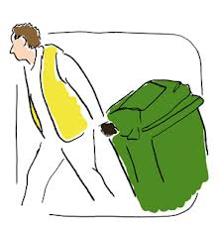](http://www.google.com.au/url?sa=i&rct=j&q=put+out+wheely+bin&source=images&cd=&cad=rja&docid=29pzR1WcQ3u_eM&tbnid=3Co3y0nBE_mw2M:&ved=0CAUQjRw&url=http://www.oxfordshire.gov.uk/cms/content/rubbish-and-recycling-oxfordshire&ei=g9A7UsKpCIKIkwWw6YH4Dg&psig=AFQjCNGHJ3ZxsU6cRHbs3zRqdJid1aroRw&ust=1379738041806358)**3** If you apply a 20 N force to a 34 kg bin. The bin will accelerate at: $(A=\frac{Force}{Mass} )$

4.

[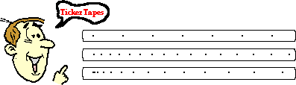](http://www.google.com.au/url?sa=i&rct=j&q=ticker+tape+speed&source=images&cd=&cad=rja&docid=wMhrNsjROP9a0M&tbnid=vzACHjSPZdrteM:&ved=0CAUQjRw&url=http://www.nileswestils.com/ILS/Acceleration.html&ei=-tA7UrGqKIfdkgXOt4HIBA&psig=AFQjCNH19iGDLCD5X9W_FaHQYkKvniD58g&ust=1379738197384806)

**A**

**B**

**C**

**What is happening with each Ticker tape experiment?**

A _________________________________________________________________________

B _________________________________________________________________________

C _________________________________________________________________________

**5. Kinetic energy is the energy of movement**

**Potential energy is stored energy**

|  |  |  |
| --- | --- | --- |
|  | Kinetic  Energy | Potential Energy |
| A skateboard moving down a hill |  |  |
| A stretched balloon. |  |  |
| A ball balanced at the top of a slide |  |  |
| A bike parked on a hill. |  |  |
| A child running. |  |  |
| A ball bouncing |  |  |
| A bumblebee hovering in the same spot. |  |  |

6. Jackson runs a race that starts and finishes at the same point. If the race was 800 metres,

What was his displacement at the end of the race?________________

What distance did Jackson run? ____________

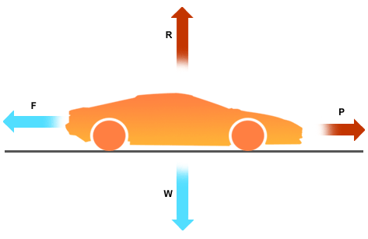7. What is happening with the forces acting on this car?

____________________________________________________

_________________________________________________________________________________________________________________________________________________________________________________________________________________________________

8. The distance travelled is: *______________________*

The displacement is ___________________________

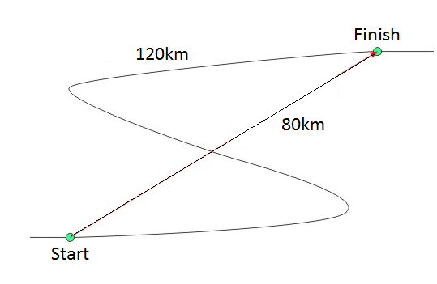.

9. Tyrell rides his bike with a constant speed of 6 m/s. It takes 200 seconds to get to school. Calculate how far away school is.

**SHOW ALL OF YOUR WORKING OUT.**

Distance= average speed x time d = v x t

d= v= t=

**10.** This table shows the speed of a Mrs Roche driving a car over time.

|  |  |
| --- | --- |
| **Speed of car (m/s)** | **Time (s)** |
| 0 | 2 |
| 40 | 4 |
| 18 | 6 |
| 10 | 8 |
| 0 | 10 |

Describe what happened in Mrs Roche’s car over time?

____________________________________________________________________________________________________________________________________________________________________________________________________________________________________________________________________________________________________________________________________

11. Give some examples of balanced forces?

__________________________________________________________________________________________________________________________________________________________________

What happens when forces are unbalanced? ___________________________________________________________________________________________________________________________________________________________________________________________________________________________________________________

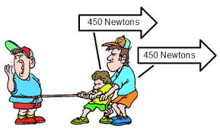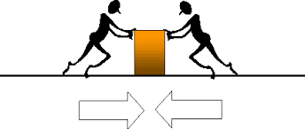What happens in each situation?

________________________________________ ______________________________________